**Download Root SSL certificate for SAP HCI**

1. Go to <https://l5366-iflmap.hcisbp.us2.hana.ondemand.com/cxf/ERP_to_EC_CostCenter_Replication_IDoc>
2. Click the lock icon at the left end of the URL and then click on certificate information.

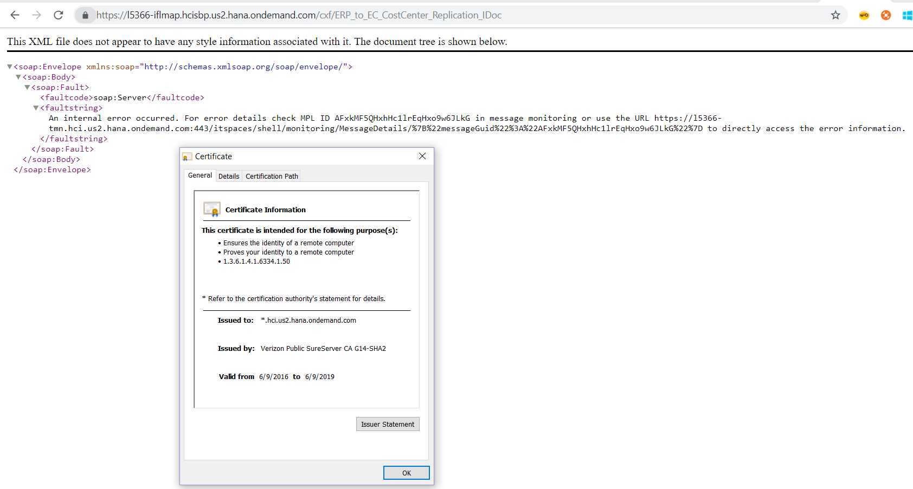

1. Go to Certification Path and click **DigiCert Baltimore Root.** Then click *View Certificate*

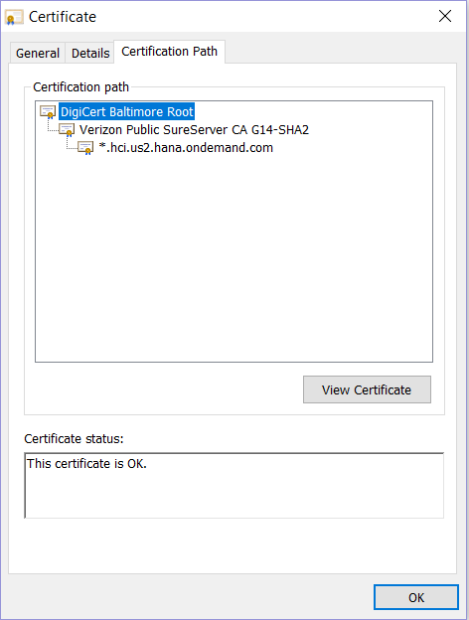

1. Go to Details and click *Copy to File* to export

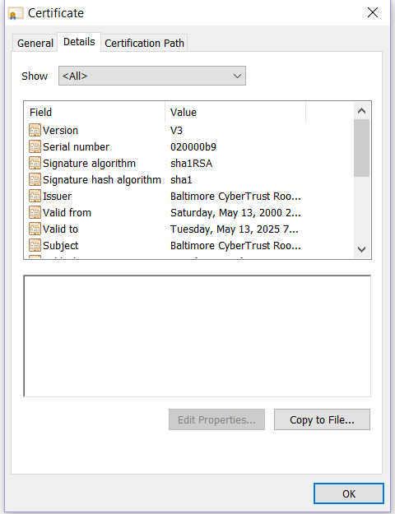

**Download Second Root SSL certificate for SAP HCI**

1. Go to <https://l5366-iflmap.hcisbp.us2.hana.ondemand.com/cxf/ERP_to_EC_CostCenter_Replication_IDoc>
2. Click the lock icon at the left end of the URL and then click on certificate information.



1. Go to Certification Path and click **Verizon Public SureServer CA G14-SHA2.** Then click *View Certificate*

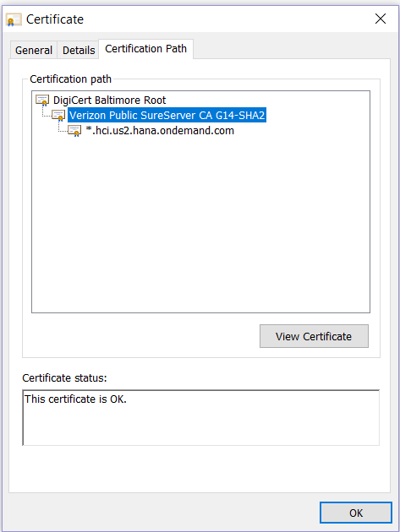

1. Go to Details and click *Copy to File* to export



**Download Third Root SSL certificate for SAP HCI**

1. Go to <https://l5366-iflmap.hcisbp.us2.hana.ondemand.com/cxf/ERP_to_EC_CostCenter_Replication_IDoc>
2. Click the lock icon at the left end of the URL and then click on certificate information.



1. Go to Certification Path and click **\*.hci.us2.hana.ondemand.com.** Then click *View Certificate*

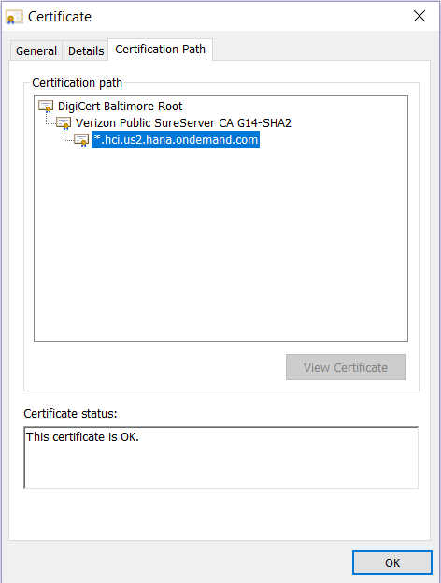

1. Go to Details and click *Copy to File* to export



**Add the Certificates in the TRUST MANAGER**

1. Call Transaction STRUST

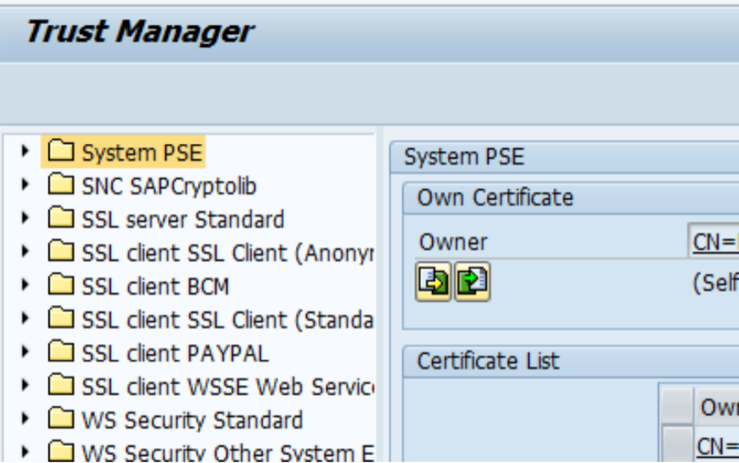

1. Open the SSL Client SSL client Standard PSE

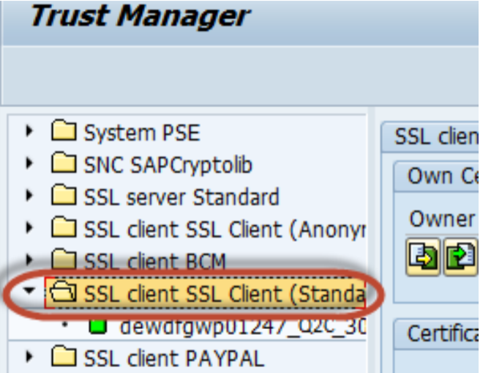

1. In the Certificate area, click Import Certificate button.

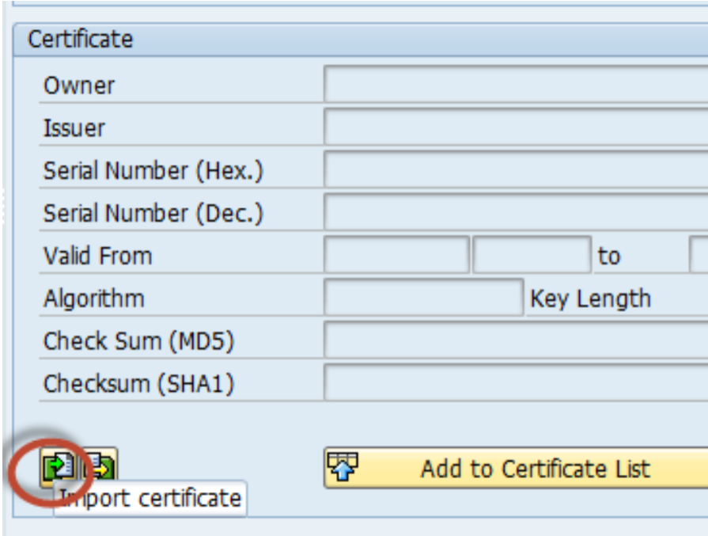

1. Depending of the format of the certificate, select either Binary or Base64 and find the root certificate used to sign the HCI SSL server certificate (Import the three certificates that were saved in the previous step)

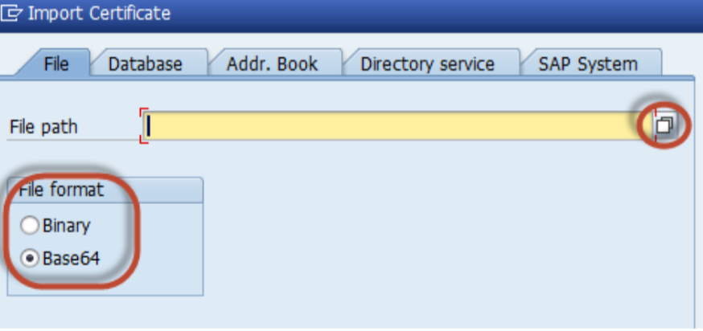

1. Add the imported certificate to the certificate list by clicking Add to Certificate List .

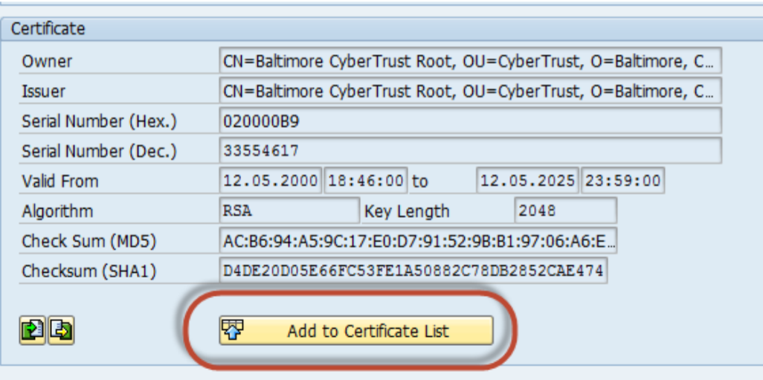

1. Save the changes.

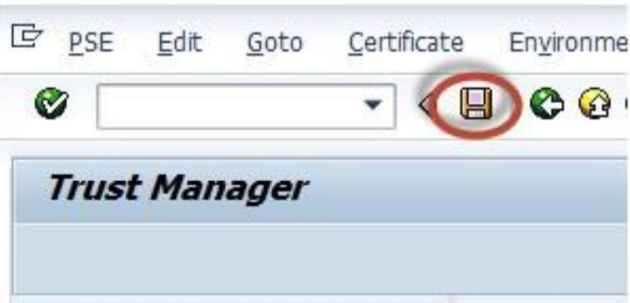

NOTE: Same certificates will work for all Replication Interfaces (Cost Center, Org Data and Employee Data)